# United College of Engineering and Management Naini, Allahabad

Project Synopsis On

NIDU

# Under the guidance Of

Mr. Anil Singh

Submitted by

Student Roll No:1834210069 Name: Princy Varma Student Roll No:1834210102 Name: Tripti Sharma Student Roll No:1834210081 Name: Shakshi Sharma Student Roll No:1903420109001 Name: Ved Prakash Pandey

**Department of Computer Science, UCEM**

## TABLE OF CONTENTS

**CONTENT PAGE NO.**

* Introduction 4
* Problem Statement 4
* Proposed Solution 5
* Scope of a project 5
* Hierarchical diagram 6
* DFD (Data Flow Diagrams) 7-8
  1. Zero level DFD 7
  2. Level-1 Physical DFD 8
* ERD (Entity Relationship Diagram) 9
* Proposed Technology/Platform 10

1. Frontend 10
2. Backend 10

* Minimum Software requirements 10
* Module Description 10-11

1. Module name 10
2. Description 10
3. Required Input 11
4. Expected output 11

* Future scope 12
* Reference 12

## Introduction:

In this project, I have tried to give all the important things and information about the project, the project title “NIDU” is builds, repair, construction, service software for the user. The project “NIDU” is developed in Web Application and Mobile Application which mainly focuses on the basic operation in an application like adding a new member, new multi services, add location, updating new information, searching services, take services and give services.

Design to help the user maintain and organize the application easily. Our software is easy to use for both beginner and advance users, it features a familiar and well-thought-out, attractive user interface, combined with strong searching, insertion, creation and reporting capabilities. The searching and creating facilities of an application system help users to find the best service or best way to earn.

The NIDU has four main modules-

* Search facility by location, photos and text
* Calling service for registration the job notification for workers (USSD)
* Insertion to database module-user friendly input screen
* Extraction from database module-attraction output screen

## Problem statement:

India is the biggest hub of working services. The worker works in different fields but still, the workers are unable to find the work which they want and most the people are not able to find workers according to their needs. As a result, we see unemployment everywhere, to decrease the unemployment we just try to manage problems which are facing by both workers and people by our project.

## Proposed Solution:

The purpose is to automate the existing manual system by the help of computerized equipment's and full-fledged computer software, fulfilling their requirements, so that their valuable data/information can be stored for a longer period with easy accessing and manipulating of the workers records and jobs. The required software and hardware are easily available and easy to work with it.

## Scope:

The scope of this project is as follows:

* To assist the workers in capturing the efforts spent on their respective areas
* To utilize resources in an efficient manner by increasing their productivity through automation
* The system generates types of information that can be used for various purposes
* It follows the quotes **a friend in need a friend in deed**

## Hierarchical Diagram

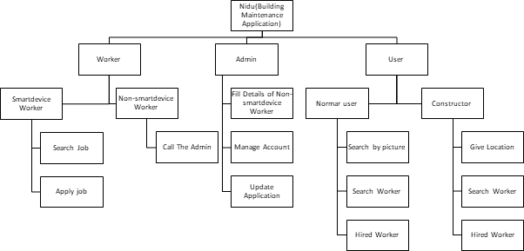

**DFD (Data Flow Diagram)**

## Zero Level DFD

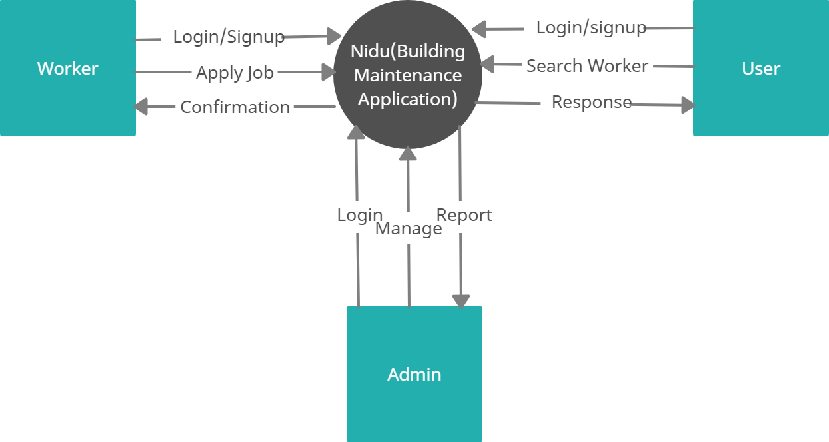

* **Level-1 Physical DFD**

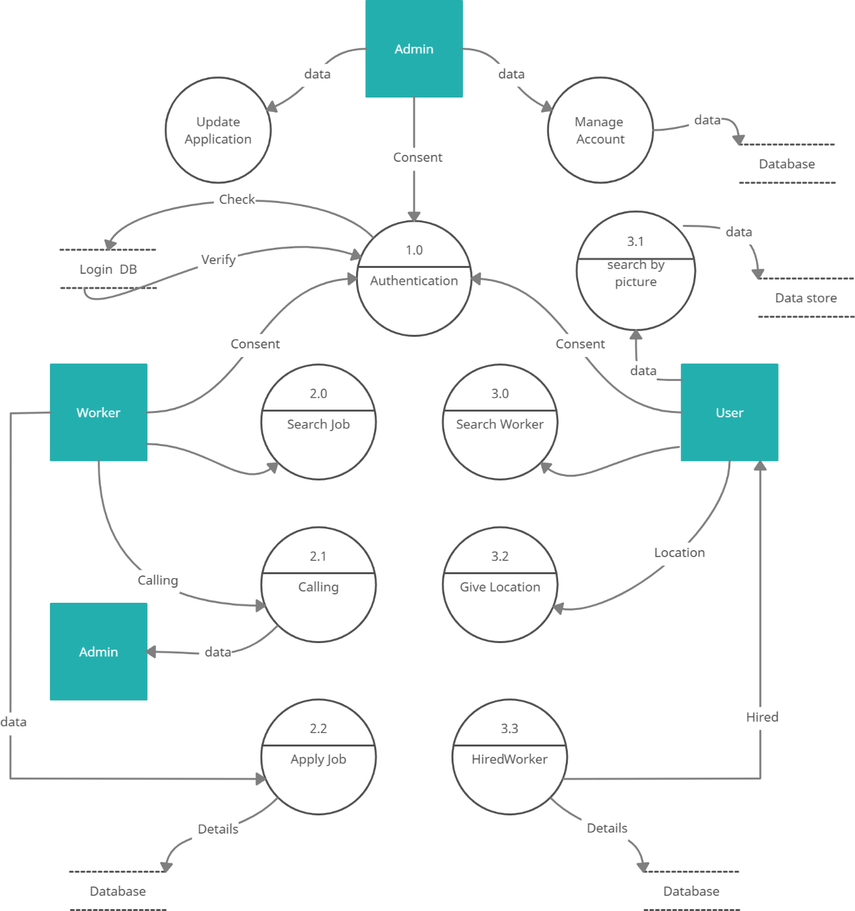

## ERD (Entity Relationship Diagram)

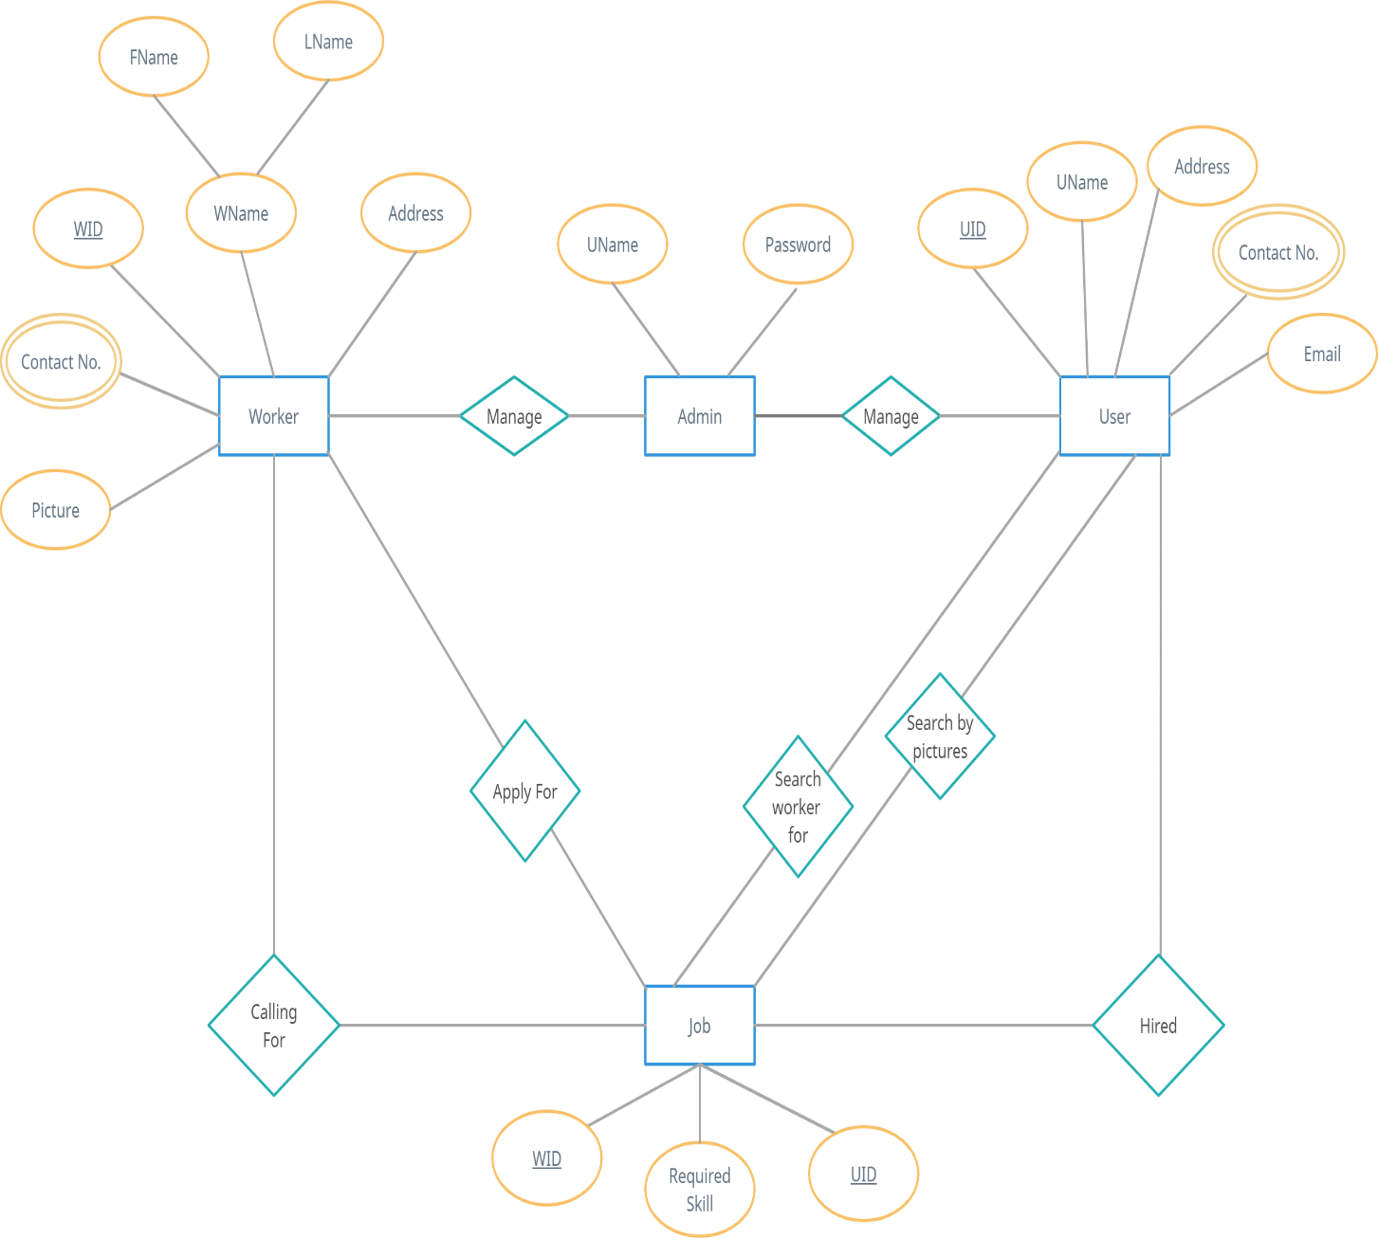

**Proposed Technology flatform**

**Front-End:** HTML (Hypertext Marker Language), CSS (Cascading Style Sheets), JavaScript, React.

**Back-End:** PHP, SQL (Structured Query Language),

## Minimum Software Requirements:

* VS Code
* MYSQL
* Git
* Postman

## Module Description:

**MODULE NAME: -NIDU DESCRIPTION:**

The project NIDU is a Web Application and Mobile Application which is used to build Repair, Construction, service software for the user. In this project we provide the service in which people are able to find worker according to their need. The system is based on online procedure. All the information about workers is available online. Those persons who want workers according to their need first they have to login and tell their problem through email or message then according to their problem NIDU suggest workers.

**REQUIRED INPUT:** All the input required for the development of this project are-

### ELECTRICIAN

* PLUMBER

### LABOR

* PAINTER

### CARPENTER

* INTERIOR DESIGN

### TILING

* MASONRY

### CLEANING

We deliver your work by verified and qualified professionals only. We pride ourselves on understanding our client concern and supplying the friendliest most approachable and most conscientious service.

## EXPECTED OUTPUT :

The present system consists of many jobs for worker such as: labor, plumber, electrician, and many more. In this worker are able to find the work without wandering. People also get a quick solution by just only one click. People have to write their budget also. NIDU suggest the worker according to the need. Person are able to see the photograph of the worker their specialization in a particular field also their cost too. NIDU also take care of their privacy. Workers valuable data/information can be stored for a longer period. Easier retrieval will be possible as multiple search facilities will be available. System takes care of security of the data.

## NIDU

## Future Scope:

This application can easily implement and easily assessable. We can add new features as when it is required in future. In NIDU we update this application NIDU is an agreement between people and the worker about the work they are to do. In future we add more skilled worker. To utilize resources in capturing manner by increasing their productivity through automation. There are plenty of opportunities for advancement. Highly experience, specialized, certified worker can become permanent in future and also, they get a job in government sector too. In future Many people connect through this application and this application grow faster. Innovation is very important the thing to grow. By this application unemployment is little bit decreasing. Workers can get job. People can get workers easily. “A job should lift workers out of poverty, not keep them in it”

## References:

[**Node.js (nodejs.org)**](https://nodejs.org/en/)

[**React – A JavaScript library for building user interfaces (reactjs.org)**](https://reactjs.org/)[**The most popular database for modern apps | MongoDB**](https://www.mongodb.com/)[**GeeksforGeeks**](https://www.geeksforgeeks.org/?ref=ghm)

[**Bootstrap · The most popular HTML, CSS, and JS library in the world. (getbootstrap.com)**](https://getbootstrap.com/)[**Font Awesome**](https://fontawesome.com/)

[**Stack Overflow - Where Developers Learn, Share, & Build Careers**](https://stackoverflow.com/)